SMART PUBLIC RESTROOM

# OBJECTIVE

❏ To design a smart public restroom which is equipped with sensor transceiver and ethernet connectivity.

❏ Remotely monitors cleanliness status of restrooms.

❏ Cleaners can be dispatched when needed instead of fixed intervals.

❏ Allow building owners and Facility Management(FM) and cleaning companies to manage usage across multiple restrooms.

❏ Using data to plan resources ahead of time based on usage patterns.

# COMPONENT LIST

1. MQ-135 AIR QUALITY SENSOR(detects NH3 in air)
2. ARDUINO UNO
3. IR SENSOR
4. 16*2 CHARACTER LED DISPLAY
5. BREADBOARD

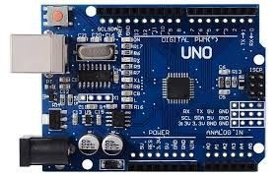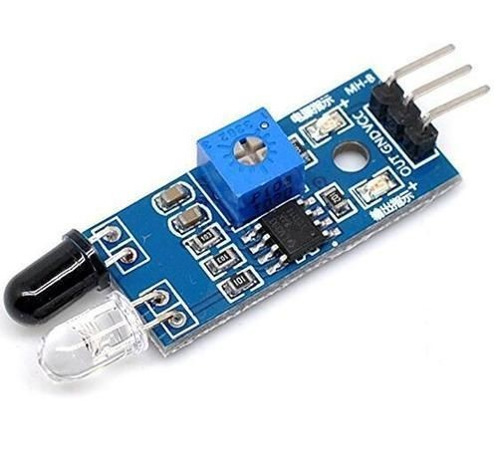

# MODEL WORKING

1. MQ-135 GAS SENSOR attached to Arduino detects the ammonia level present in the air and displays the ammonia level in ppm on the LED display.
2. IF ammonia level is more than 1.5 ppm then green led is switched on indicating to start the fan
3. IF ammonia level is greater than 2.5 ppm then red led is switched on giving an indication to clean the toilet because the smell is unbearable.
4. Also,if a person enters and leaves the toilet the usage count is detected by IR sensor and is incremented by one.

# DEVICE OUTPUT

❏ Device performs various tasks based on the ammonia level present in the restroom as follows

|  |  |
| --- | --- |
| DETECTED AMMONIA LEVEL IN PPM | TASK PERFORMED |
| 0 - 1.5 | No Significant Smell(No task performed) |
| 1.5 - 2.5 | Bearable Smell (Put fan on) |
| 2.5 and above | Unbearable smell (Clean toilet urgently) |

❏ IR sensor increments the person count by one when a person enters and leaves the restroom.Thus,track of toilet usage is monitered .

DATASET



Thank You!